**Airline Reservation System**

S.E. mini-project report submitted in partial fulfilment of the requirements of the degree of

**Information Technology**

by

**Siddhesh Santosh Chavan EU1194007 (01)**

**Reenav Keshav Hemaria EU1194028 (07)**

**Aishwarya Ajay Ingale EU1194033 (08)**

**Shubham Virendra Kerkar EU1194042(12)**

Under the guidance of

**Mrs. Linda John**

**(Assistant Professor)**



**Department of Information Technology**

**St. John College of Engineering and Management, Palghar**

**University of Mumbai**

2020–2021

**CERTIFICATE**

This is to certify that the S.E. mini-project entitled **“Airline Reservation System”** is a bonafide work of

**“Siddhesh Santosh Chavan (EU1194007) (01)** , **Reenav Keshav Hemaria (EU1194028) (07)**, **Aishwarya Ajay Ingale (EU1194033) (08)** , **Shubham Virendra Kerkar (EU1194042)(12)”**

submitted to University of Mumbai in partial fulfilment of the requirement for the award of the degree of **“Information Technology Engineering”** during the academic year 2020-2021.

**Mrs. Linda John**

(Assistant Professor)

Guide

**Mrs. Anita Chaudhari** **Dr. G.V. Mulgund**

Head of Department Principal

ii

**S.E. Mini-Project Report Approval**

This mini-project synopsis entitled ***Airline Reservation System***  by **Siddhesh Chavan, Reenav Hemaria, Aishwarya Ingale, Shubham Kerkar** is approved for the degree of ***Information Technology Engineering*** from ***University of Mumbai***.

**Examiners**

1.---------------------------------------------

2.---------------------------------------------

Date: Place: 

**Declaration**

We declare that this written submission represents our ideas in our own words and where others’ ideas or words have been included, we have adequately cited and referenced the original sources. We also declare that we have adhered to all principles of academic honesty and integrity and have not misrepresented or fabricated or falsified any idea/data/fact/source in our submission. We understand that any violation of the above will be cause for disciplinary action by the Institute and can also evoke penal action from the sources which have thus not been properly cited or from whom proper permission has not been taken when needed.

---------------------------------------

                                                  Signature

Siddhesh S. Chavan (EU1194007)

---------------------------------------

                                                  Signature

Reenav K. Hemaria (EU1194028)

---------------------------------------

                                                  Signature

Aishwarya A. Ingale (EU1194033)

---------------------------------------

                                                  Signature

Shubham V. Kerkar (EU1194042)

Date: 

**Abstract**

The project has been developed to carry out the processes of reservation of flights and scheduling of flights. It also includes the conventional way to save data. Passport information and criminal’s record. The Airline

reservation system take over a project based on this technology. The project is analyzed about requirements about the reservation system of flights. In this project we are using java core language and MySQL as database

***Keywords—****Airline Reservation, online reservation system,Java.*

**Table of Contents**

|  |  |  |
| --- | --- | --- |
|  | **Abstract** | **v** |
|  | **List of Figures** | **vii** |
|  | **List of Tables** | **viii** |
|  | **List of Abbreviations** | **ix** |
| **Chapter 1** | **Introduction** | **1** |
|  | 1.1 Motivation | 3 |
|  | 1.2 Problem Statement | 4 |
|  | 1.3 Scope | 6 |
| **Chapter 2** | **Review of Literature** | **7** |
| **Chapter 3** | **Requirement Analysis** | **8** |
|  | 3.1 Hardware and Software Requirements | 4 |
|  | 3.2 UML Diagrams ( ER Diagram ) | 5 |
| **Chapter 4** | **Report on Present Investigation** | **9** |
|  | 4.1 Proposed System | 10 |
|  | 4.1.1 Block diagram of Proposed System | 11 |
|  | 4.2 Implementation | 12 |
|  | 4.2.1 Algorithm/Flowchart | 13 |
|  | 4.2.2 Dataset(If used in your project) | 14 |
|  | 4.2.3 Pseudo code | 15 |
|  | 4.2.4 Screenshots of the output with description | 16 |
| **Chapter 5** | **Results and Discussion** | **20** |
| **Chapter 6** | **Conclusion** | **21** |
|  | 6.1 Conclusion | **22** |
|  | **References** | **23** |
|  | **Acknowledgement** | **24** |

**List of Figures**

|  |  |  |
| --- | --- | --- |
| **Figure No.** | **Figure Name** | **Page No.** |
| 3.1 | ER Diagram | 12 |
| 4.1 | Block Diagram | 13 |
| 4.2 | Flow Chart | 14 |

*.*

**List of Abbreviations**

|  |  |
| --- | --- |
| **SJCEM** | St. John College of Engineering and Management |
|  |  |
|  |  |
|  |  |
|  |  |
|  |  |
|  |  |
|  |  |
| ARS | Airline Reservation System. |
| CRS | Computer Reservation System. |
| GDS | Global Distribution System. |
| PSS | Passenger Service System. |

**Chapter 1**

**Introduction**

An airline reservation system (ARS) is part of the so-called passenger service systems (PSS), which are applications supporting the direct contact with the passenger. ARS eventually evolved into the computer reservations system (CRS). A computer reservation system is used for the reservations of a particular airline and interfaces with a global distribution system (GDS) which supports travel agencies and other distribution channels in making reservations for most major airlines in a single system.

* 1. **Motivation**

Today all persons are busy with their schedule and no one have time to make a trip for holidays with their family. And this Airline Reservation Process is very difficult to understand in General meaning. But we are providing a Solution for that Problem. This system provides a facility to easy access towards a customers and a real time users. They can easily connected through it and just 3 steps. There is no requirement for any type of Agent. We are giving a all this facility in one project “Airline Reservation System”.

* 1. **Problem Statement**

1. The current system is manual, this system is slow, time consuming and it is very difficult for each person to book through office agents. Users inquire about the tickets through phones and it is very difficult for the user to remember all the details that they received through phones. It is very difficult to calculate how many peoples registered and how many seats on a particular plane are vacant .This requires quite a lot of time and wastage of money as it requires quite lot of manpower to do.

**1.3 Objectives**

The objectives are as follows:

* To make the airline information system online based.
* To reduce number of registers and documents.
* To enable the passengers to save their time by using quick reservation.
* Easy to maintain the records.
* To reduce the time needed to reduce this job.
* To store the data in organized form.

**1.4 Scope**

We are trying to give a live reporting which is updated by Airline Companies so that customer gets a live Flights checking, Available seats, Pricing and also planning to provide seats as per theirs choice so that they can travel very comfortably their journey. We will trying to provide food facility and choice to customers so that they can feel like their home and more effective amenities. We are also trying to make more attention on Business class people and their requirements.

Our future planning is to take this project towards an AndroidApp and QR Code Scanning. So that a Customer can easily contact to the Airlines and they are getting quick Services from Airlines.

We also want in future to place in market so that customer can take more advantages and saves their important time. We are also finding and approaching to companies which are using this type of software.

**Chapter 2**

**Review of Literature**

Title: - To decrease manual stress for reservation of flight. A literature survey/ review.

Authors names: -

1. Anuradha Prajapati

2. Kirti Dhirwani

3. Manisha Agarwal

4. Nandita Gurwara

5. Seria Tak

Journal name: - International Journal of research advanced ideas and innovation in technology.

DESCRIPTION: - The survey is based on the decrease manual stress and increase the use of technology. From anywhere you can book tickets without wasting your time.

ADVANTAGE: - Decrease manual stress

DISADVANTAGES: -Failure to travelers to chose a seat for their picked flight

**Chapter 3**

**Requirement Analysis**

**3.1 Hardware and Software requirements:**

1. Apache Netbeans IDE 12.1

2. MySQL Workbench 8.0 CE

3. PC with i3 Processor,4GB RAM.

**3.2 UML Diagrams ( ER Diagram ):**

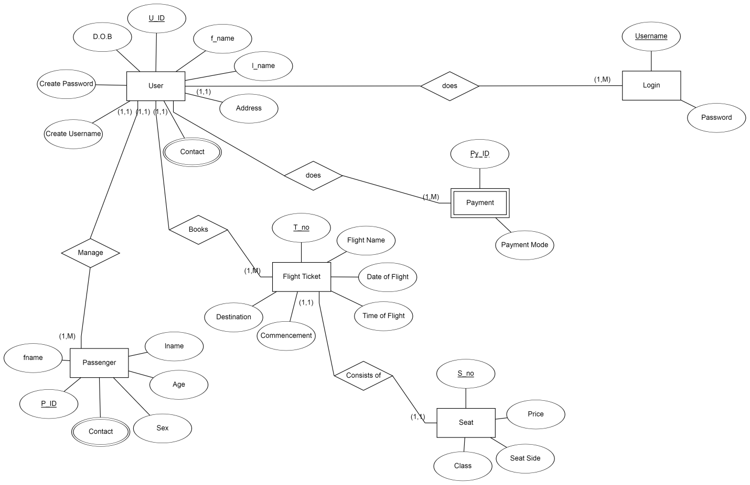

**3.1 ER Diagram**

**Chapter 4**

**Reports on present Investigation**

**4.1 Proposed System**

**4.1.1 Block diagram of Proposed System**

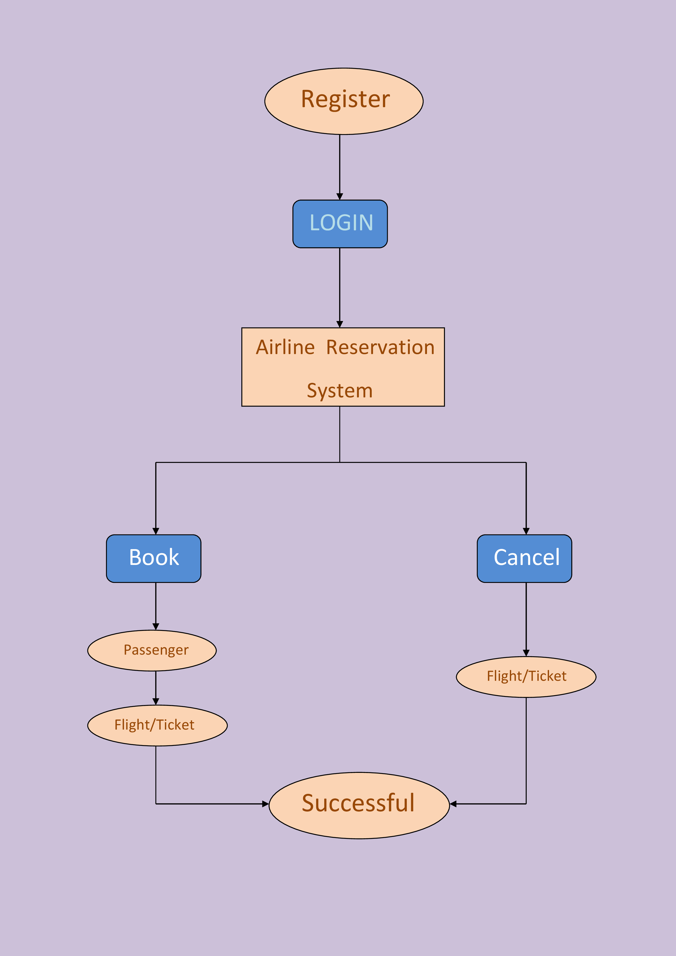

**4.1 Block Diagram**

**4.2 Implementaion**

**4.2.1 Algorithm and flow chart.**

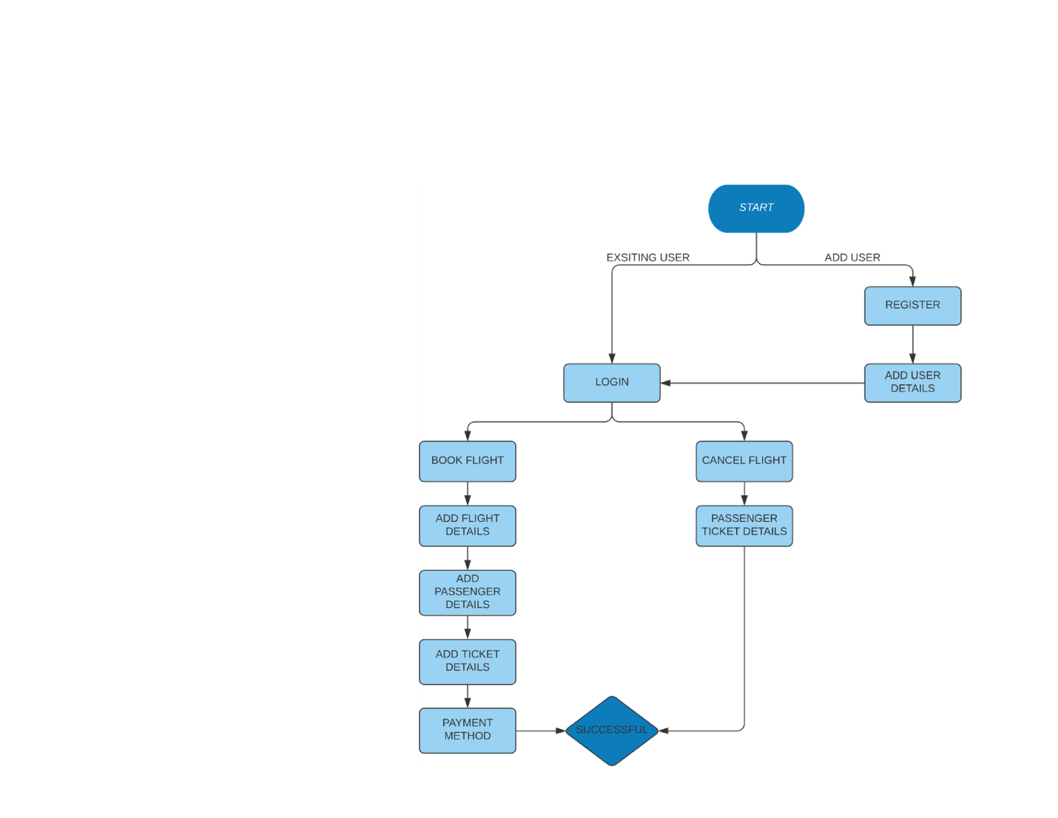

**4.2 Flow Chart**

**4.2.3 Psuedo Code**

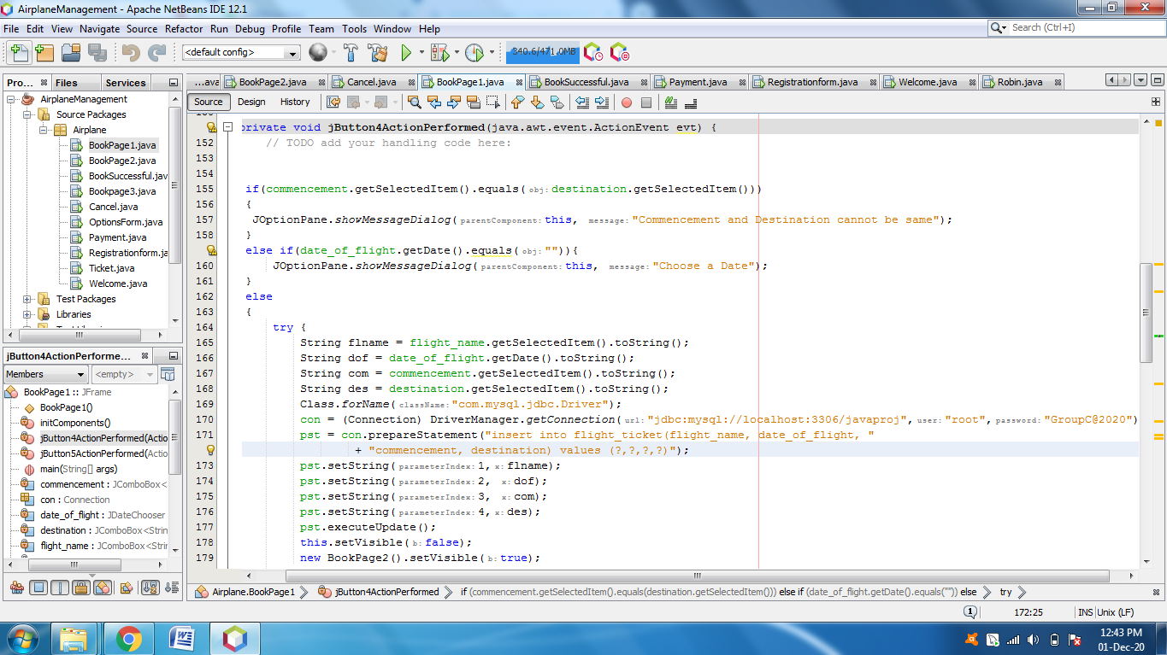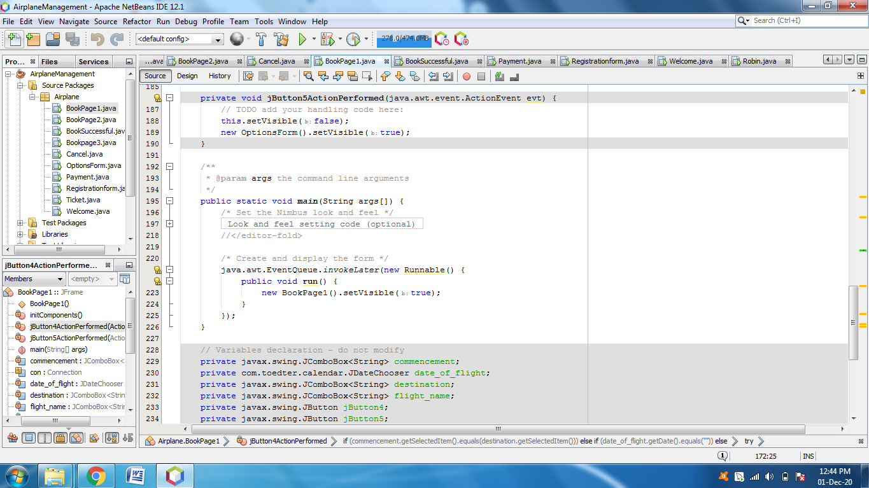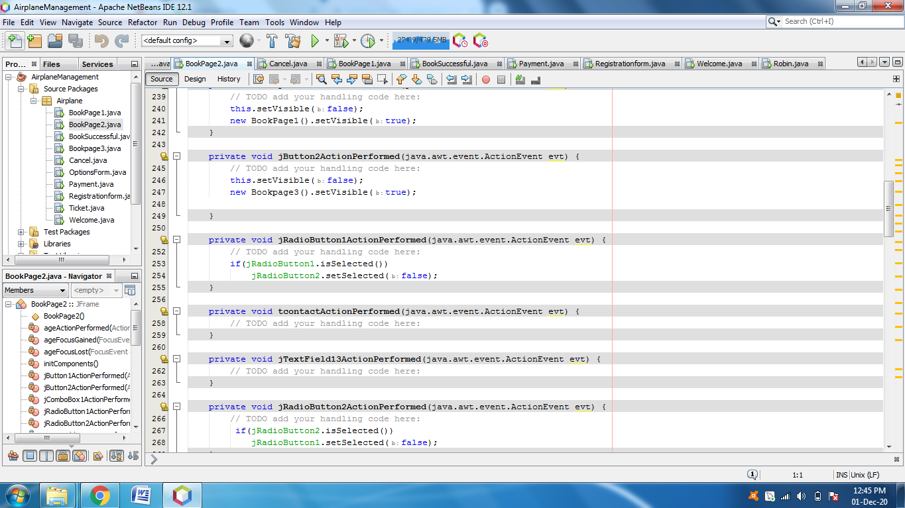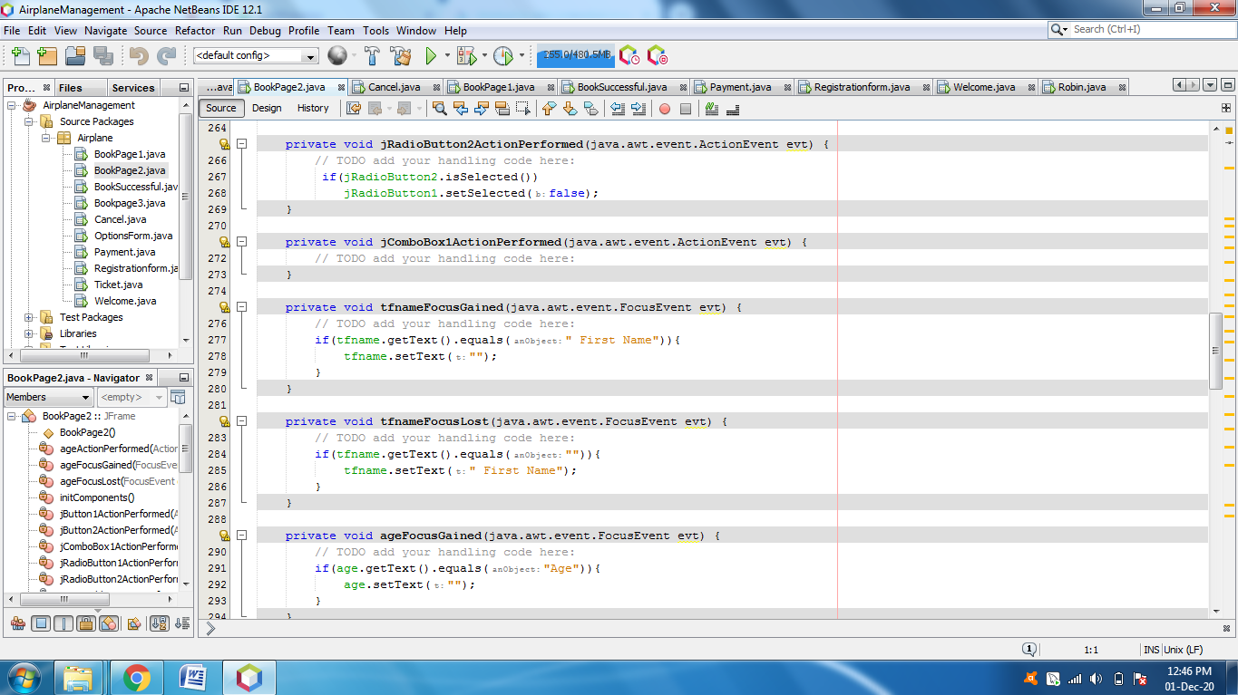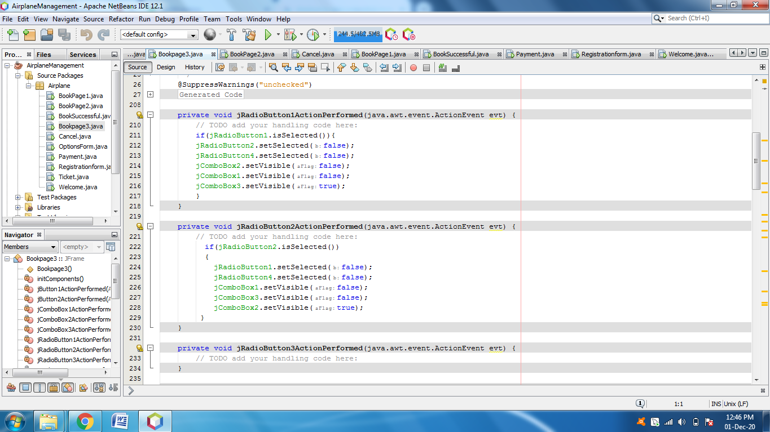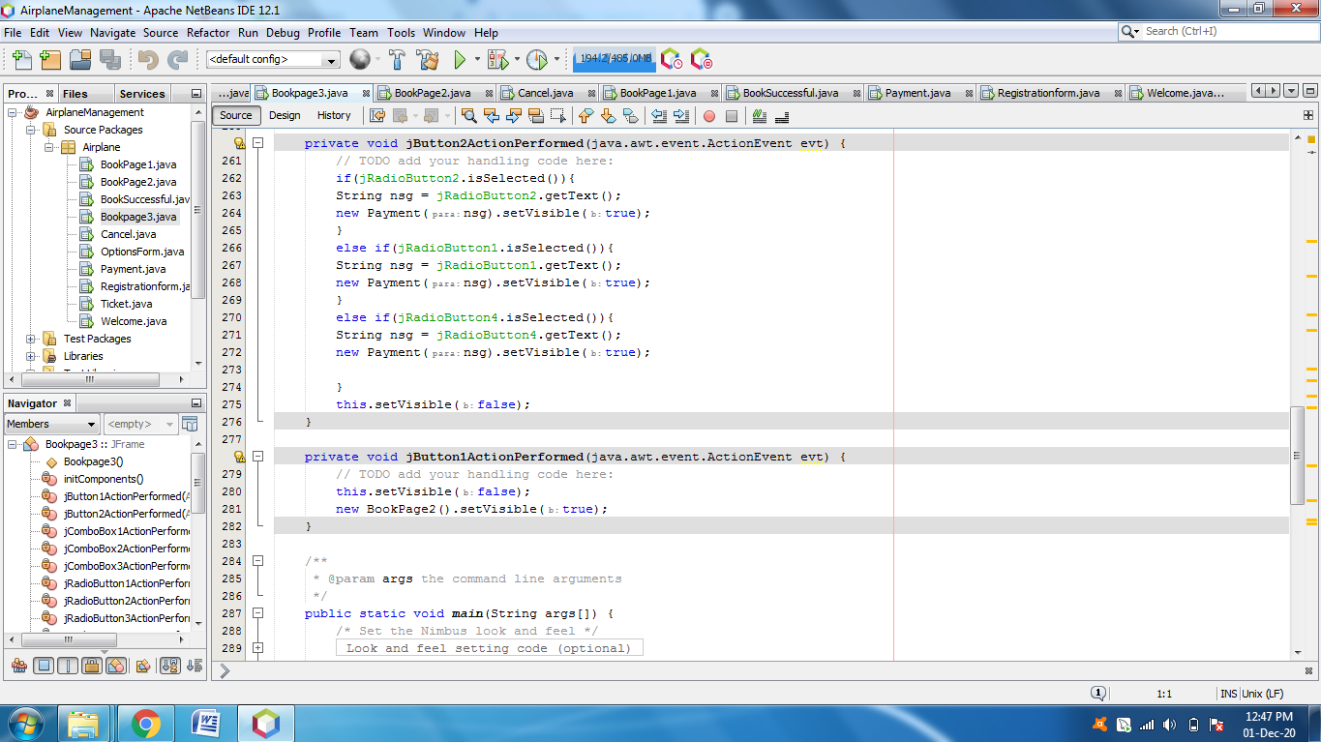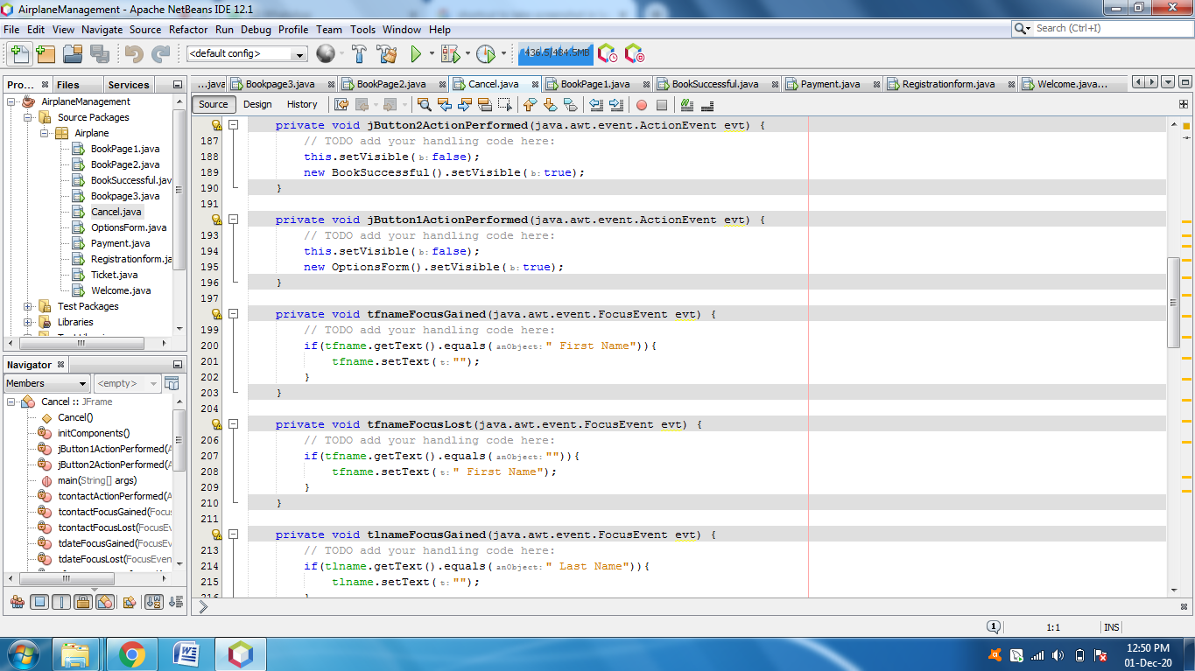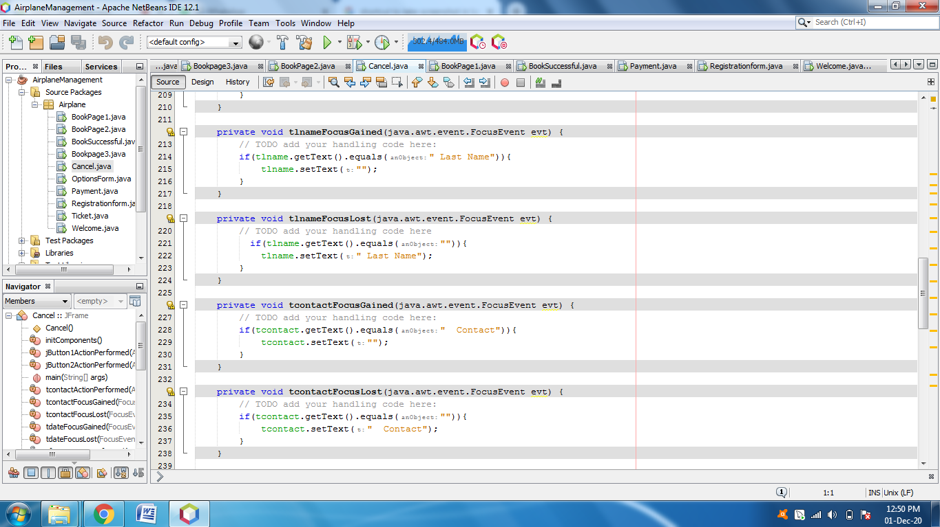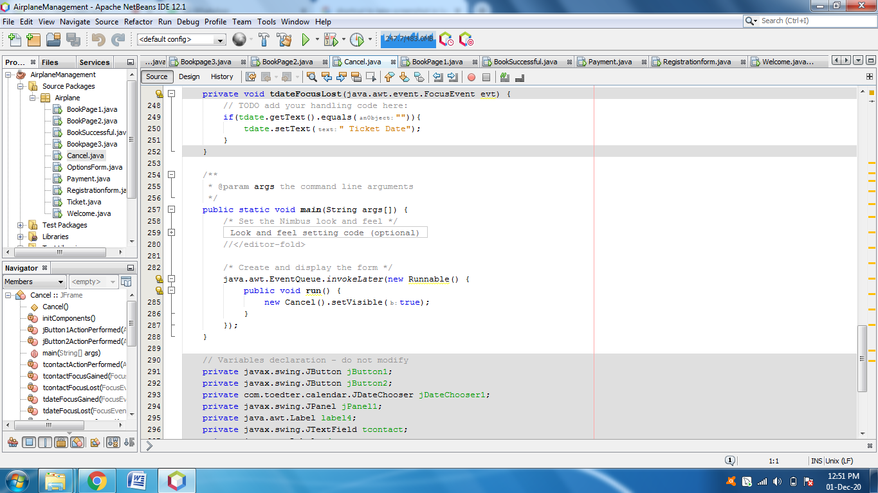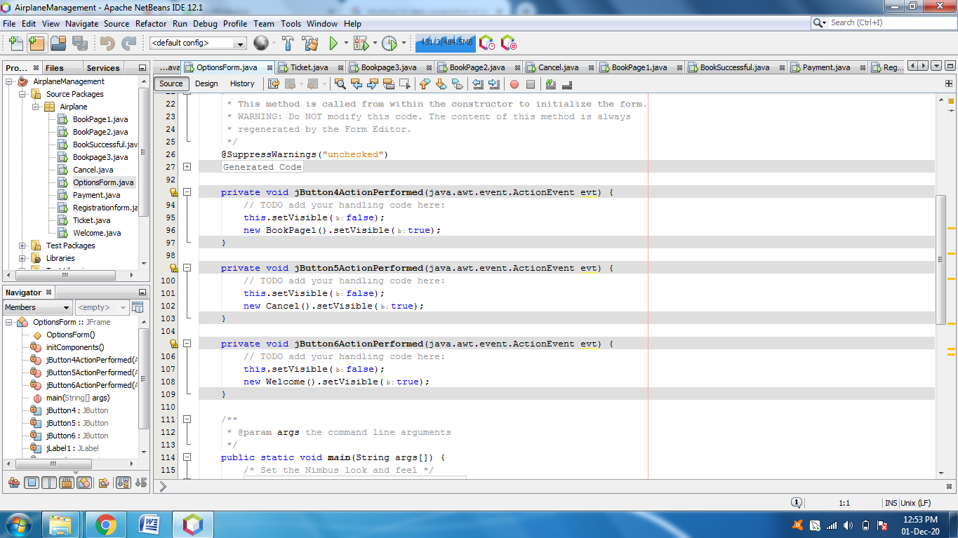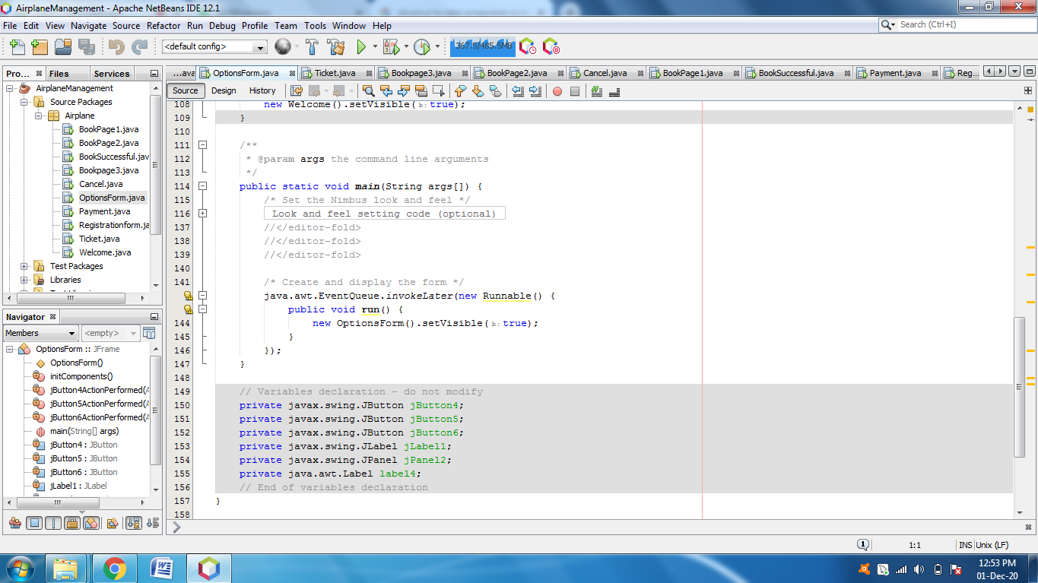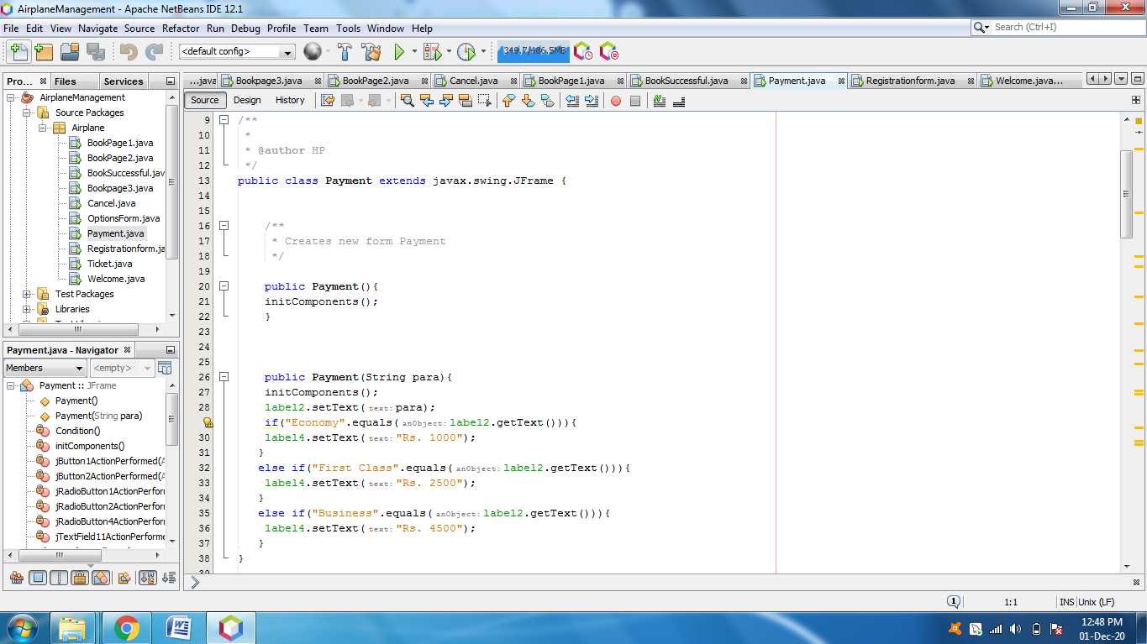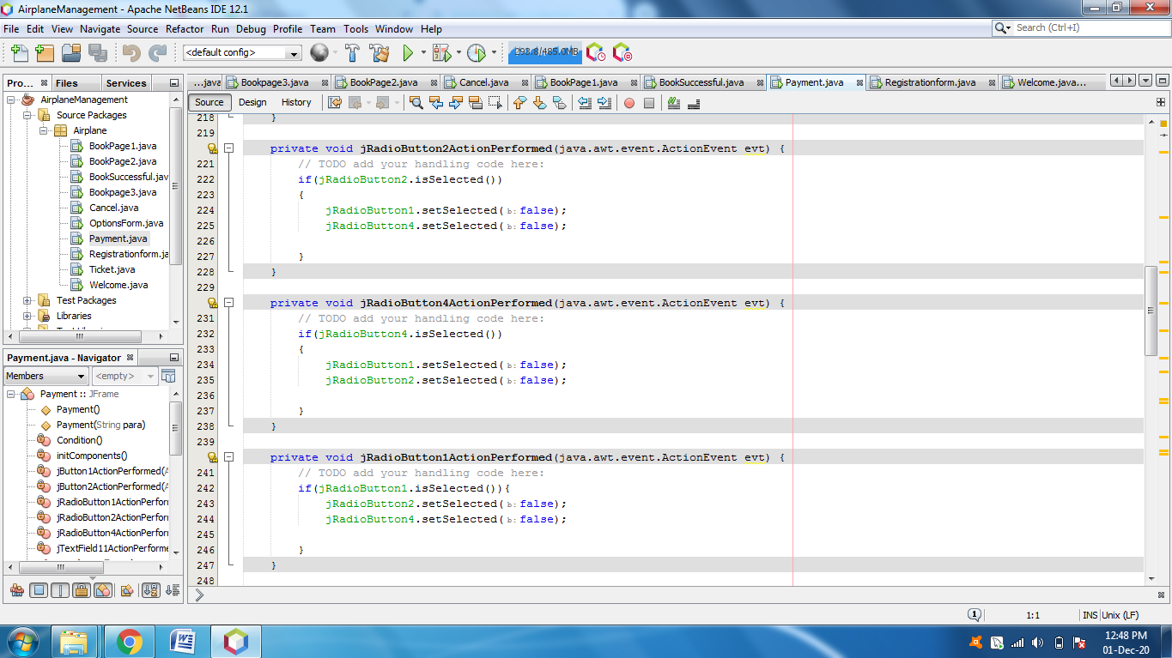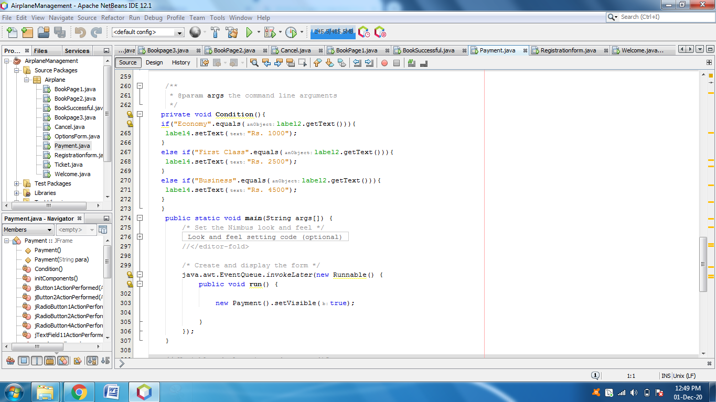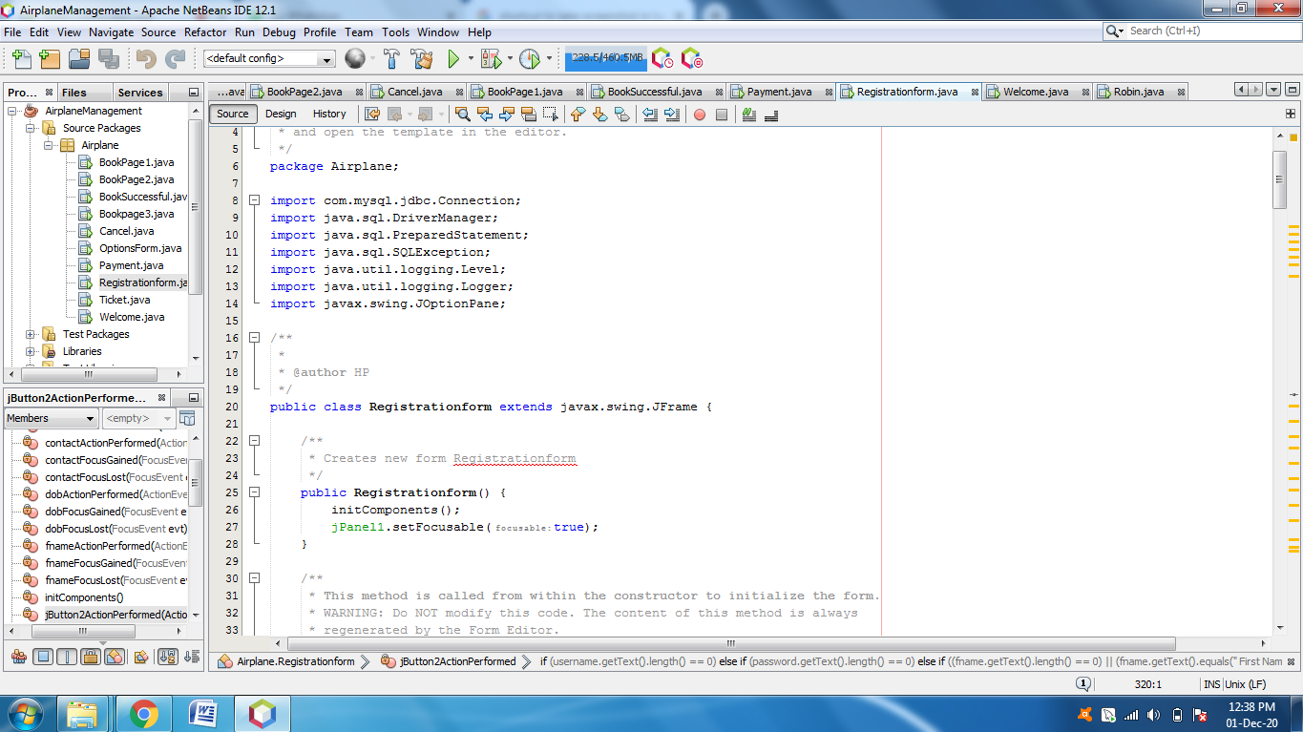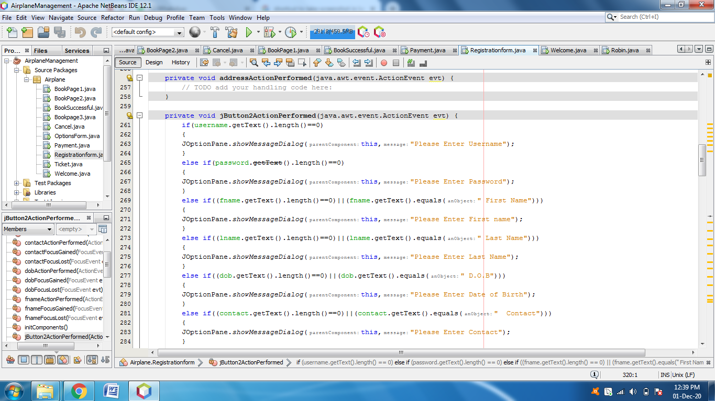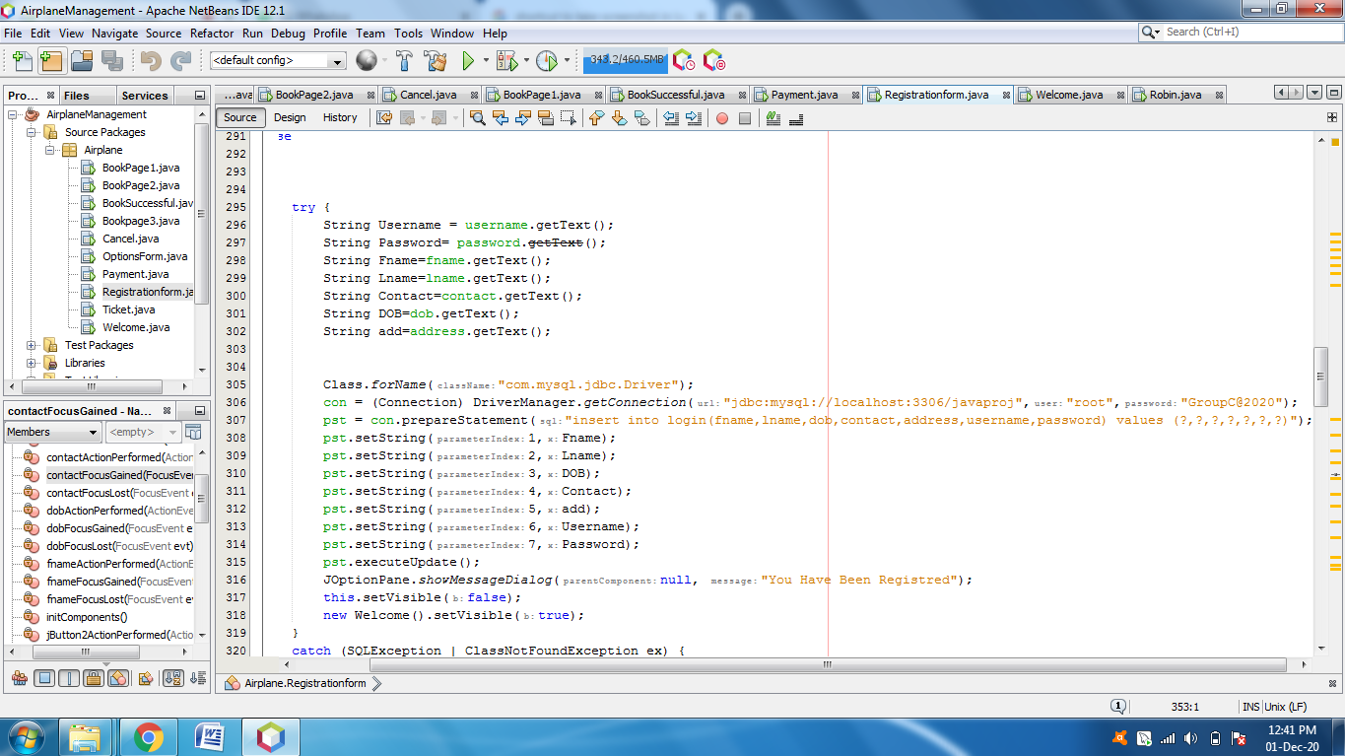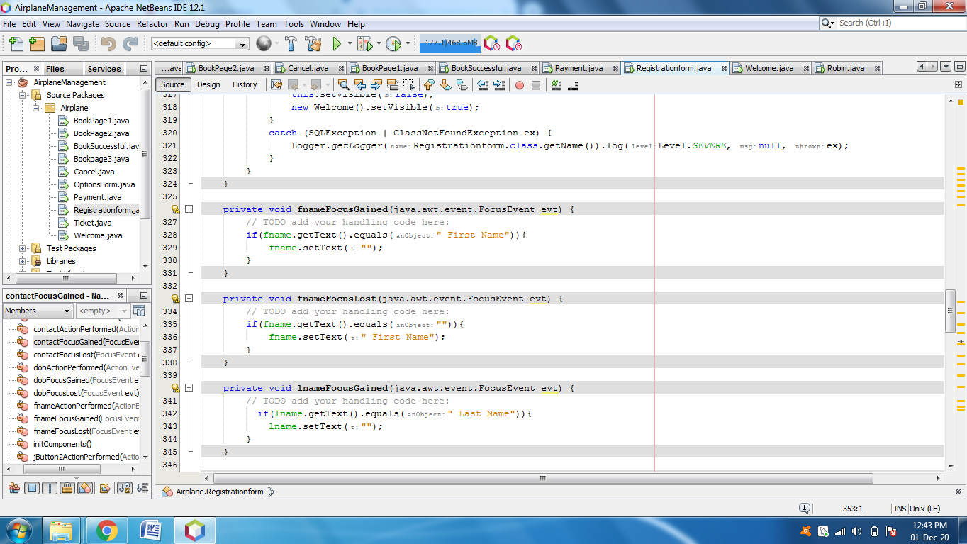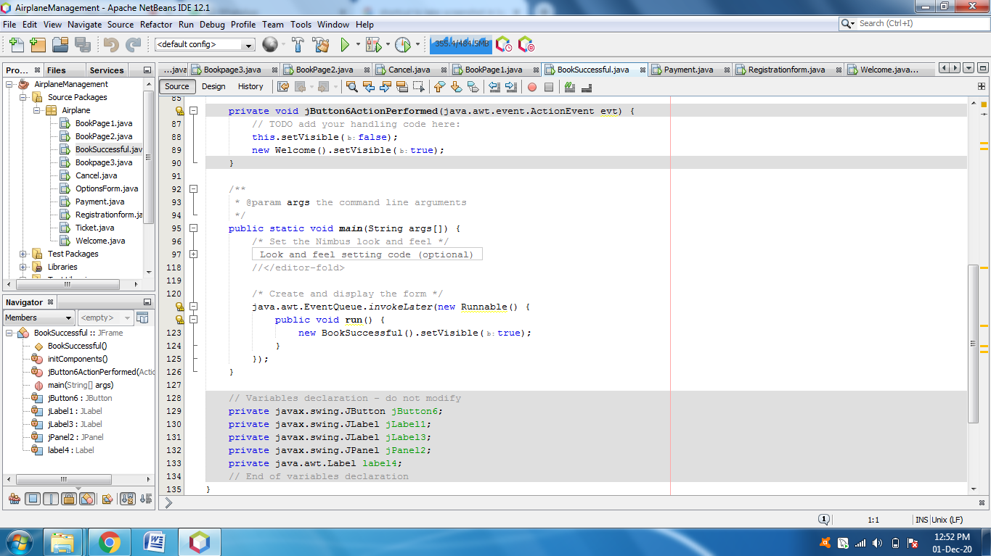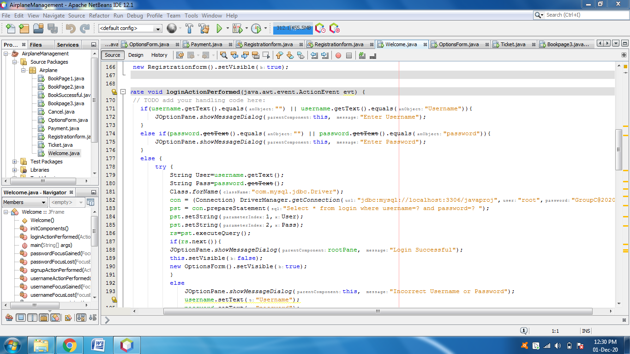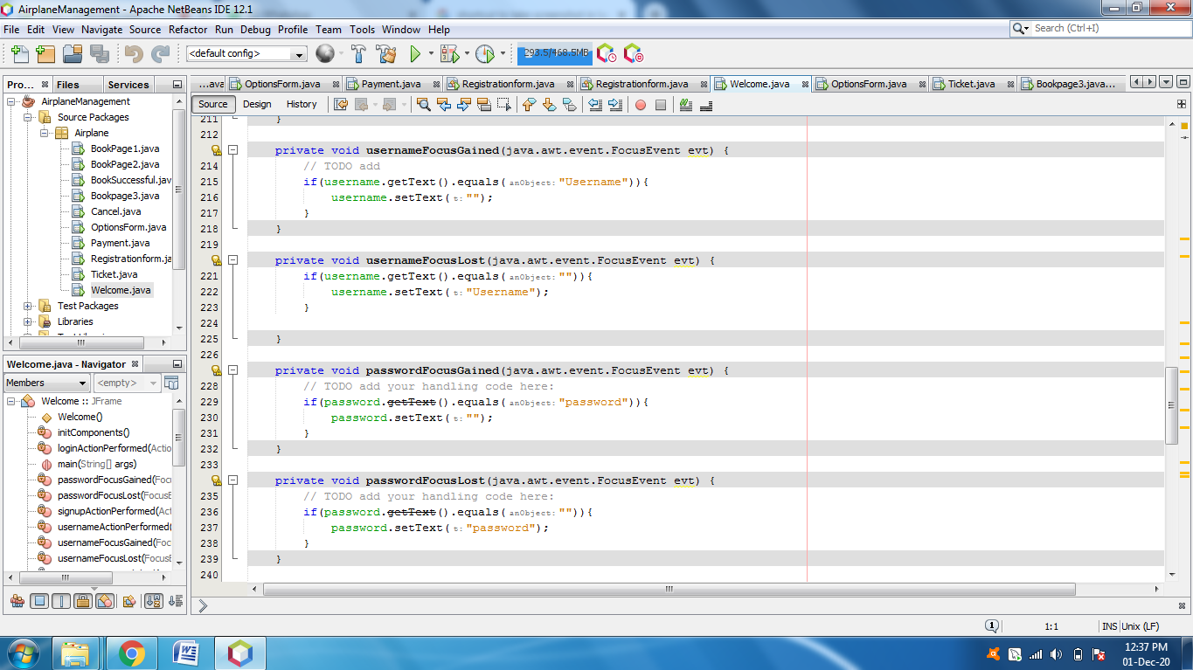

**4.2.4 Screenshots of output with description.**

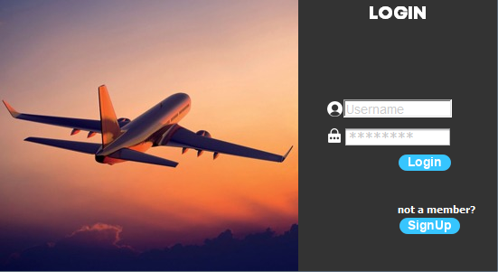

**Login Page:**

You can login through using your username and password, And if you are not a member you can sign up by clicking on sign up button.

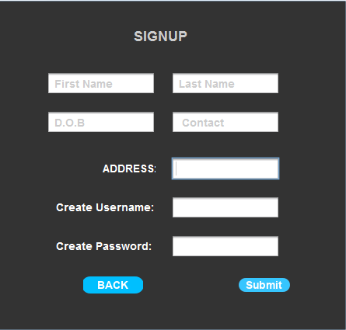

**Registration Page:**

After clicking on sign up button you will be redirected to “Registration Page”. On this Page you have to put all your credentials as asked on the page and you have create a username and password for your account.



**Option Page:**

Here the user can choose between booking a flight or cancelling a flight ticket.

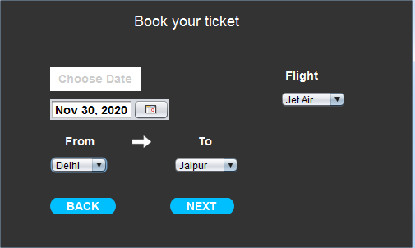

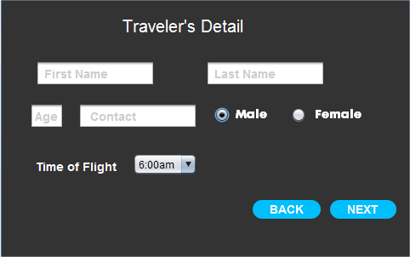

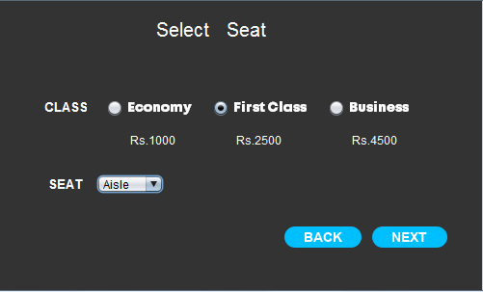

**Booking pages:**

After successful login you can book your tickets as per your convenience.

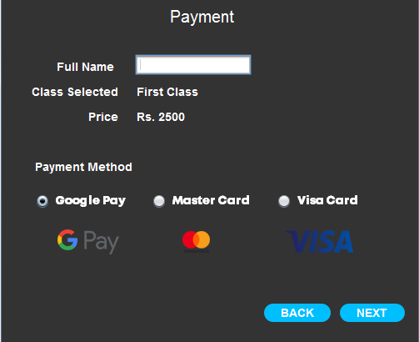

**Payment Page:**

After Booking your ticket payment page will appear. Here you have to enter your payment credential and select your payment method.

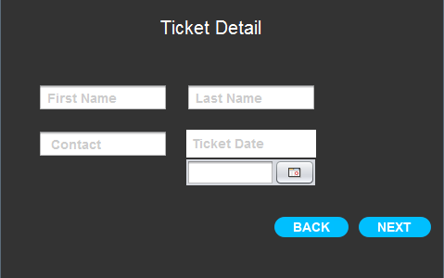

**Cancel Page:**

Here you have to enter your ticket and passenger details to cancel your booked flight ticket if you want to.



**Successful:**

After successfully booking/cancelling your ticket this successful page will appear. By clicking on logout button you will be redirected to login page.

**Chapter 5**

**Result and Discussion**

Successfully implemented Airline Reservation System using software like Apache Netbeans IDE 12.1 and MySQL for database management.

Forms are created using Java SWING method.

**Chapter 6**

**Conclusion**

**Conclusion:**

The “Airline Reservation System” was successfully designed and is tested for accuracy and quality. During this project we have accomplished all the objectives and this project meets the needs of the organization. The developed will be used in searching, retrieving and generating information for the concerned requests. The advantages that are with this proposed system are Reduced entry work, Easy retrieval of information ,Reduced errors due to human intervention, User friendly screens to enter the data, Portable and flexible for further enhancement ,Web enabled and Fast finding of information requested.

**REFERENCES:**

1. Java Complete Reference by Herbert Shield

2. Database Programming with JDBC and Java by George Reese

3. Java and XML By Brett McLaughlin

4. Wikipedia, URL: http://www.wikipedia.org.

5. Answers.com, Online Dictionary, Encyclopedia and much more, URL: http://www.answers.com

6. Google, URL: http://www.google.co.in

7. Project Management

URL: http://www.startwright.com/project.html

**Acknowledgement:**

In performing our project, we had to take the help and guideline of some respected persons, who deserve our greatest gratitude. The completion of this project gives us much Pleasure. We would like to show our gratitude Mrs. Linda John for giving us a good guideline for project throughout numerous consultations. We would also like to expand our deepest gratitude to all those who have directly and indirectly guided us in writing this assignment.

In addition, a thank you to Professor Mr.Ahmer Usmani , who introduced us to the Methodology of work, and whose passion for the “underlying structures” had lasting effect.